|  |  |
| --- | --- |
|  | |
|  | **Proposal to the**  **Office of Systems Integration (OSI)**  **Request for Information (RFI) #75001**  **For**  **Agile Development Pre-Qualified (ADPQ) Vendor Pool**  **Attachment A – ADPQ Vendor Profile**  **June 9, 2016** |

|  |
| --- |
|  |



|  |  |
| --- | --- |
|  |  |

*Strategy! Innovation! Transformstion!*

Revision History

|  |  |  |  |
| --- | --- | --- | --- |
| Version | Date | Description of Updates | Author |
| DRAFT | 05/30/2016 | First Draft version created | xFusion |
| 1.0 | 06/08/2016 | Updates made based on review comments and final version created | xFusion |
|  |  |  |  |
|  |  |  |  |

Table of Contents

1. Vendor Information 5

2. Parent corporation name and/or subsidiaries. 5

3. Company Overview 5

4. Contact Persons 7

5. git repository 7

# Vendor Information

|  |  |
| --- | --- |
| **Name** | xFusion Technologies |
| **Address, city, state, and zip code** | 2893 Sunrise Boulevard, Suite 202  Rancho Cordova, CA 95742 |
| **Phone Number** | (916) 990-6484 |

# Parent corporation name and/or subsidiaries

xFusion Technologies acquired SynergyQuad, Inc., in May 2014. As of January 2016, SynergyQuad, Inc., became a fully-owned subsidiary of xFusion Technologies.

# Company Overview

xFusion Technologies, Inc. is a State of California Certified Small Business (1758792) headquartered in Rancho Cordova, California. Founded in 2010, we are a DGS CMAS organization (Contract Number: 3-13-70-3001A) that specializes in serving various Public and Private sector organizations. We bring years of expertise in Business, Information and Technology Architecture, Strategy, Systems Integration, Product Development, Enterprise Architecture (EA), Service Oriented Architecture (SOA), Micro-services Architecture, Modern UX/UI technologies, Big Data ecosystem, Machine Learning, Data Visualization, Business Process Management (BPM), and Legacy Systems Modernization with specific subject matter expertise in the Health and Human Services industries.

With a combined strentgth of 27 employees and contractors we offer a full spectrum of IT services which are delivered via our Practices and Expertise in the areas of Enterprise Architecture, Custom Product Development, Outsourced Product Development, and Data Warehousing and Analytics services.

**Our Services**

At xFusion, we understand that Business-Technology alignment is the key to enabling an on-demand organization. Following are our Key Service Areas:

* **Technology Strategy and Architecture:** Understand the business strategy and help define technology architecture and strategy using the “top-down” approach, while following industry-accepted practices and frameworks.
* **Systems Integration and Product Engineering:** Help clients solve their toughest system implementation and integration challenges utilizing modern architectural and open standards/source technology and best practices.
* **Data Engineering:** Offer end-to-end data engineering services – data, architecture, strategy, data integration, analytics, and data visualization.
* **Training, Coaching and Mentoring:** Provide training that spans from basic education, to advanced role-based training.

**Our Products and Solutions**

Our products and solutions include best of the breed frameworks, Micro-services API, in-premise and cloud-based Software as a Service (SaaS) solutions:

* **xPlore™:** Legacy modernization architecture, strategy, and Business Rules Extraction (BRE) for efficient and cost effective results.
* **xCellence™:** Enterprise asset lifecycle management and Governance as a Service (GaaS), allowing management of dependencies between the enterprise assets for effective change impact analysis.
* **xClaim™:** Cloud-based solution for claims submission, adjudication, and accounting functions for various types of Health Care and Public Welfare Programs.
* **xMod API™:** Modular, Reusable and Interoperable Microservices API that provides common Technical Services capabilities. The technical services APIs are reusable and can be shared by any service or application across an organization, that significantly reduces implementation and operational costs.

**Our Key Public Sector Customers**

* Covered California
* California Department of Health Care Services (DHCS)
* California Department of Social Services (CDSS)
* Washington Sate Health Care Authority
* Mississippi Division of Medicaid
* NYC Health
* California Highway Patrol (CHP)
* Sacramento Municipal Utility District (SMUD)
* Office of Systems Integration (OSI)
* CalSTRS

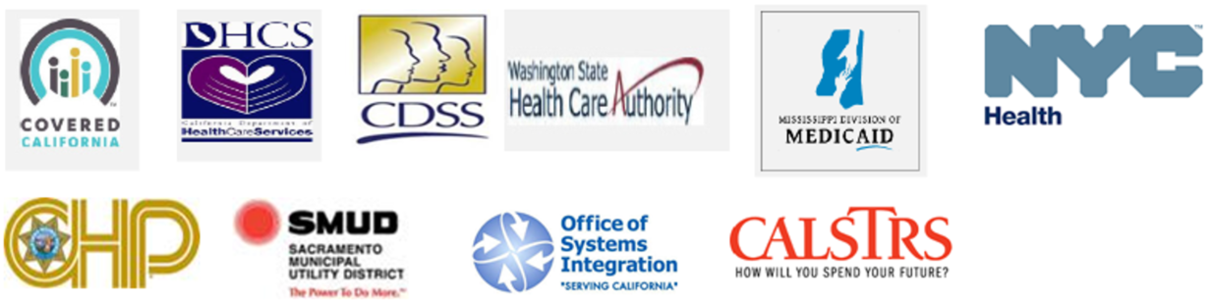

**Our Health and Human Services Expertise**

xFusion’s Health and Human Services practice brings years of experience serving various private and public Health and Human Services organizations that uniquely qualify us to establish an agile, interoperable and reusable Health Enterprise Architecture. We assist in the Technology Strategy and Architecture, Design, and Implementation of State and Private health information exchanges and modernize the legacy Medicaid Management Information Systems (MMIS).

**HHS Enterprise Architecture (MITA, OBHITA, NHSIA)**

xFusion provides Enterprise Architecture service to various organizations to establish an integrated and coor­dinated Physical Health, Behavioral Health and the Human Services Enterprise Architecture, conduct MITA State Self-Assessment (SS-A), and establish the roadmap for the Health Enterprise Transformation.

**Healthcare Interoperability**

Healthcare Interoperability is the capability of different information systems in the Healthcare ecosystems to communicate, exchange, and process data effectively and efficiently in order to advance the effective delivery of healthcare for individuals and communities. xFusion’s subject matter expertise ranges from Programs/Policies to Technology, Architecture, Standards, Best Practices and Solution Frameworks.

**Legacy Modernization Strategy, Architecture, and Business Rules Extraction (BRE)**

Knowledge In-Sourcing is extremely critical – analyze and document your existing business processes, Stakeholders, Use Cases, Technical Architecture & Components, Data, and Business Rules and identify and document the challenges and pain points associated with your current environment.

Our integrated framework, xPlore™, is built with process, tools and best practices that will help end-to-end Legacy Systems Modernization planning effort from As-Is Architecture Analysis, To-Be Architecture and Strategy Definition and Funding and Procurement phases in an extremely efficient and cost effective manner.

**Human Services**

xFusion brings multifaceted expertise in Human Services programs such as Temporary Assistance for Needy Families (TANF), Supplemental Nutrition Assistance Program (SNAP), In-Home Support Service (IHSS) and Child Welfare Services, as well as Human Services Enterprise Architecture expertise, National Human Services Interoperability Architecture (NHSIA).

# Contact Persons

|  |  |  |
| --- | --- | --- |
|  | **Primary** | **Secondary** |
| **Name** | Sanjib Nayak | Allison Garcia |
| **Title** | CEO | Operations Manager |
| **Address** | 2893 Sunrise Boulevard, Suite 202, Rancho Cordova, CA 95742 | 2893 Sunrise Boulevard, Suite 202, Rancho Cordova, CA 95742 |
| **Phone Number** | (916) 990-6484 | (916) 668-6021, ext. 115 |
| **Email Address** | [sanjib.nayak@xfusiontech.com](mailto:sanjib.nayak@xfusiontech.com) | [agarcia@xfusiontech.com](mailto:agarcia@xfusiontech.com) |
|  |  |  |

# 

# git repository